Time series analyses of changes in asymmetric relationships among members over time (2)

Naohito Chino
Department of Psychology, Aichi Gakuin University

Handout presented at the 44th Annual Meeting of the Behaviormetric Society of Japan, August 31, 2016
Ebetsu, Japan

The organization of my talk

- Introduction
- Why a Hilbert space model?
- Nonlinear difference equation models
- Possible dynamical scenarios of solutions
- Relations to dissipative structure and so on (Chino, 2016)
- Linear and non-linear TSA of changes in asymmetric relationships

- Introduction

We have been developing difference equation models which describe and predict changes in asymmetric relat-
ionships among members over time (2000, 2002, 2006, 2014, 2015a, b). Members may be various objects which are observed in various branches of sciences, such as nations, humans and other animals, cells, and so on. In this paper we shall distinguish between complex difference equation and real difference equation.
First, we assume the following complex difference equation model as one type of models which describe changes in the above relationships (here, we shall call it Model I):

$z_{j, n+1}=z_{j,n}+\sum_{m=1}^{q}{\sum_{k≠j}^{N}{D_{jk,n}^{\left(m\right)}f^{\left(m\right)}\left(z_{j,n}-z_{k,n}\right)}}, j=1, 2, ⋯, N,$
(1)
Here,

$f^{\left(m\right)}\left(z_{j,n}-z_{k,n}\right)={\left({\left(z_{j,n}^{\left(1\right)}-z_{k,n}^{\left(1\right)}\right)}^{m}, {\left(z_{j,n}^{\left(2\right)}-z_{k,n}^{\left(2\right)}\right)}^{m},…,{\left(z_{j,n}^{\left(p\right)}-z_{k,n}^{\left(p\right)}\right)}^{m}\right)}^{t},$ (2)
and
$D_{jk,n}^{\left(m\right)}=diag\left(w_{jk,n}^{\left(1,m\right)},w_{jk,n}^{\left(2,m\right)}, …,w_{jk,n}^{\left(p,m\right)}\right).$ (3)

Here, $z_{j,n}$ denotes the coordinate vector of member j at time n in a p-dimensional Hilbert space or a p-dimensional indefinite metric space (Chino & Shiraiwa, 1993). Moreover, m denotes the degree of the vector function $f^{\left(m\right)}\left(z_{j,n}-z_{k,n}\right)$, which is assumed to have the maximum value q. Moreover, $w_{jk,n}^{\left(1,m\right)},w_{jk,n}^{\left(2,m\right)}, …,w_{jk,n}^{\left(p,m\right)}$ are complex constants. This model is very general and might enable us to describe various possible changes in asymmetric relationships among members over time.

- Why a Hilbert space model?
As is stated above, the state space in one of our models is assumed to be a p-dimensional Hilbert space or a p-dimensional indeﬁnite metric space. The reason why we choose these spaces comes from a fundamental theorem on the asymmetric multidimensional scaling (abbreviated as asymmetric MDS) developed by Chino and Shiraiwa (1993).
This theorem tells us that any asymmetric relationships among members of a group at any time can be embedded in the Hilbert space under a mild condition. The asymmetric MDS model based on this theorem is called the Hermitian Form Model (HFM). In the original HFM, the relationship data are measured at a ratio scale level.

- Nonlinear difference equation model
It should be noticed here that the above theorem merely
specifies the appropriate state space in which members of
a group are located at an instant in time. In contrast,
the goal of our study is to predict changes in asymmetric
relationships through various interactions among members of
a group over time, given a set of longitudinal asymmetric
relationship data matrices, S₁,S₂, …, S_{T}. Here, S_{n} denotes
the asymmetric relational data matrix at time n.
Since the above theorem provides us with the configu-
ration of members on the space at each time, we can
obtain a set of longitudinal configuration matrices, Z₁, Z₂,
…, Z_{T}. Here, let us denote $z_{j,n}$ as the p-dimensional co-
ordinate vector of member j at time n. The $z_{j,n}$ is the very
vector which appeared in one of our difference equation
models, i.e., Model I.
We need some appropriate model which predicts
changes in these coordinate vectors of each member over
time. A possible candidate for such a model may be the
nonlinear difference equation model discussed above.

Model II
The other Another type of model is a real version of the
above complex difference equation model. In general,
any p-dimensional Hilbert space as well as indefinite
metric space may be viewed as a 2p-dimensional Euc- lidean space. As a result, this type of model can be said to be a real difference equation model. In this case, we assume more specific changes in asymmetric relationships among members. That is, we assume that the members obey the following three basic principles of interpersonal behaviors (e.g., Chino, 2015a, b):

- The asymmetric sentiment relationships among members make their affinities change.
- If a member has a positive sentiment toward another member, then he or she moves toward the target member.
- If a member has a negative sentiment toward another member, then he or she moves away from the target member.

At this point, it should be noticed that according to the
real version of HFM, similarity of member j to member k
at a given time in a two-dimensional Euclidean space can
be written as

$s_{jk}=λ\left(x_{j1}x_{k1}+x_{j2}x_{k2}\right) +λ\left(x_{j2}x_{k1}-x_{j1}x_{k2}\right),$
$=λ\left|x_{j}\right|\left|x_{k}\right|\left(\cos{θ_{jk}}-\sin{θ_{jk}}\right)$, (4)

where $θ_{jk}$ is the angle from $x_{j}$ to $x_{k}$ in the counterclock-
wise direction, and ranges from 0 to 2π.

$θ_{jk}$ $x_{j}$
$x_{k}$

From Eq. (4) we have,
$s_{jk}=μ_{jk}\left(\cos{θ_{jk}}-\sin{θ_{jk}}\right),$ $s_{kj}=μ_{kj}\left(\cos{θ_{jk}}+\sin{θ_{jk}}\right),$
(5)
where $μ_{jk}=λ\left|x_{j}\right|\left|x_{k}\right|.$ It is apparent from Eq. (5) that we can obtain the following four five patters of similarities between two members, according to the angle between members j and k, i.e., $θ_{jk.}$
Moreover, in a two-dimensional Euclidean space, Eq. (1)
reduces to the following simple form in the case when q equals 1:

$x_{j,n+1}=x_{j,n}+w_{jk}\left(x_{j,n}-x_{k,n}\right)$,
$x_{k,n+1}=x_{k,n}+w_{kj}\left(x_{k,n}-x_{j,n}\right)$,
(6)

where $x_{j,n}$ is the coordinate vector of member j at time n in the two-dimensional Euclidean space.
If members obey the basic principles assumed above, then the signs of $w_{jk}$ and $w_{kj}$ corresponding to those of $s_{jk}$and $s_{kj}$, respectively, must be chosen as shown in Table 1 or Table 2, depending on the angle$\left(x_{j,n}\right)$ and angle$\left(x_{k,n}\right)$. Here, angle$\left(x\right)$ is the MATLAB angle func-
tion, and ranges from −π to π.

To clarify this issue we depicted the following figure. To simplify the situation, we assumed that $μ_{jk}$ in Eq. (5) is equal to 1. In this figure, $s_{jk}$ and $s_{kj}$ in Eq. (5) are drawn by the black line and the red line, respectively. Furthermore, the curve with green line indicates absolute skewness between members, j and k. Here, the skewness between the two members can be generally defined as
$s_{jk}-s_{kj}=-2μ_{jk}\sin{θ_{jk}}$.
Therefore, for simplicity, we define the absolute skewness
as $\left|\sin{θ_{jk}}\right|$ .
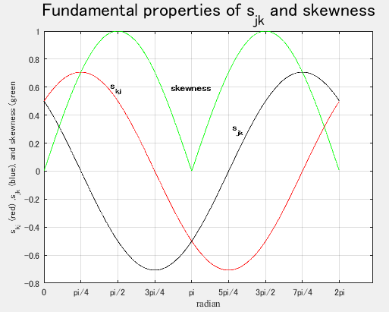

The five patterns mentioned above correspond to the
intervals in the horizontal axis, which are shown in
Tables 1 and 2 of my manuscript in the proceedings.
In these tables there are a few errata. You should revise
the signs of $w_{jk}$ and $w_{kj}$ as well as $s_{jk}$ and $s_{kj}$ in Case
4 of Table 1 as follows:

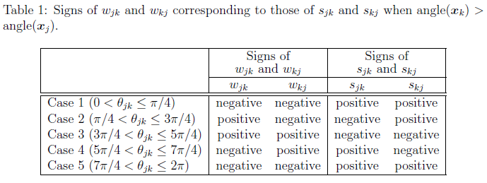

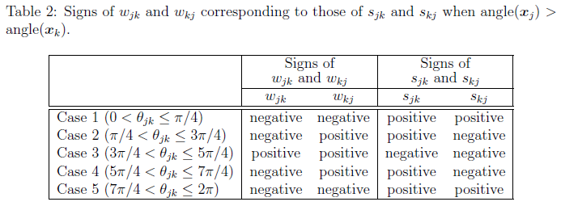
Here, the signs of $w_{jk}$ and $w_{kj}$ are determined accord-
ing to the three basic principles of the interpersonal
behaviors discussed above. However, if we add another
principle, for example, the balance principle proposed by
Heider (1958) to our principles, these signs should be
revised. Such a principle leads to another model. We
shall call it Model III.

Model IV
A fourth type of model is the model in which $w_{jk,n}^{\left(l,m\right)}$ is specified further in Model I. That is,
$z_{j, n+1}=z_{j,n}+\sum_{m=1}^{q}{\sum_{k≠j}^{N}{D_{jk,n}^{\left(m\right)}f^{\left(m\right)}\left(z_{j,n}-z_{k,n}\right)}}, j=1, 2, ⋯, N,$ (1)
$f^{\left(m\right)}\left(z_{j,n}-z_{k,n}\right)={\left({\left(z_{j,n}^{\left(1\right)}-z_{k,n}^{\left(1\right)}\right)}^{m}, {\left(z_{j,n}^{\left(2\right)}-z_{k,n}^{\left(2\right)}\right)}^{m},…,{\left(z_{j,n}^{\left(p\right)}-z_{k,n}^{\left(p\right)}\right)}^{m}\right)}^{t},$ (2)
and
$D_{jk,n}^{\left(m\right)}=diag\left(w_{jk,n}^{\left(1,m\right)},w_{jk,n}^{\left(2,m\right)}, …,w_{jk,n}^{\left(p,m\right)}\right).$ (3)
$w_{jk,n}^{\left(l,m\right)}=a_{n}^{\left(l, m\right)}r_{j,n}^{\left(l, m\right)}r_{k,n}^{\left(l, m\right)}\sin\left(θ_{k,n}^{\left(l, m\right)}-θ_{j,n}^{\left(l, m\right)}\right)$,
l =1, 2, …, p, m =1, 2, …, q. (6)

Here, $a_{n}^{\left(l, m\right)}$ is a real constant, and $r_{j,n}^{\left(l, m\right)}$ and $θ_{j,n}^{\left(l, m\right)}$ are, respectively, the norm and the argument of $z_{j,n}$ at time n on dimension l. As a result, $w_{jk,n}^{\left(l,m\right)}$ is a real variable which depends on both $r_{j,n}^{\left(l, m\right)}$ and $r_{k,n}^{\left(l, m\right)}$ as well as both $θ_{k,n}^{\left(l, m\right)}$ and $θ_{j,n}^{\left(l, m\right)}$ Usually, it is assumed that both $r_{j,n}^{\left(l, m\right)}$ and $r_{k,n}^{\left(l, m\right)}$ are independent of m.
As pointed out in Chino (2014b), however, the two terms, $r_{j,n}^{\left(l, m\right)}$ and $θ_{j,n}^{\left(l, m\right)}$are functions of $z_{j,n}$and its complex conjugate, ${\overline{z}}_{j,n}$. This means that $z_{j,n}$ in Eq. (1) is not a holomorphic function, since the complex conjugate of $z_{j,n}$ is not differentiable in the complex space (e.g., Bak & Newman, 1982). To overcome this difficulty, we may consider the complex state space in this model as a 2p-dimensional Euclidean space.

Model V
We have recently considered another type of model in which two terms in Eq. (1), i.e., $g\left(u_{j,n}\right)$and $z_{0},$ are added, the former being a control (e.g., Elaydi, 1999; Ott et al., 1990) and the latter a complex constant vector (Chino, 2015b). Here, $g\left(u_{j,n}\right)$ is a vector function of a complex vector $u_{j,n}$.

In this paper we shall show some results of a small
simulation study on the two types of models Model I,
which include linear and nonlinear time series analysis
(Chino, 2015a, b) of the resultant time series signals
obtained by these types this model.

- Possible dynamical scenarios of solutions
Figure 1 is a possible scenario of the solution of Model I, in which case $w_{jk}= 0.01\left(1+i\right)$, and $w_{kj}=-0.02\left(1+i\right)$.
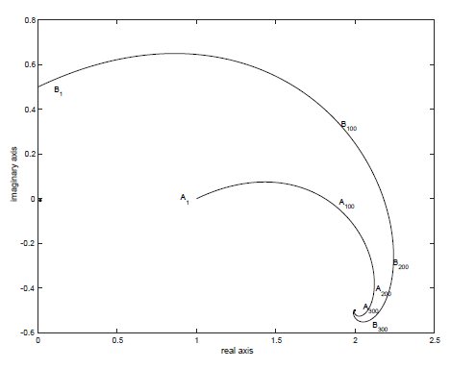
Figure 1. Changes in trajectories of a dyad in a one-dimensional Hilbert space.

It shows the trajectories of a dyad in one-dimensional Hilbert space. Two members A and B located at 1 and 0.5i, respectively, approach to each other gradually, and converge to an equilibrium point. It is not so difficult to prove mathematically that these trajectories converge to a fixed point.
Figure 2 depicts the stroboscopic configurations of these two members recovered from the above trajectories. We can see that the two members gradually approach to each other as time proceeds.
Figure 3 draws changes in self-similarities of these members as well as the angle between them over time. We can see that the self-similarities increase at an earlier stage, begin to decrease gradually, and converge to fixed values asymptotically at the final stage.
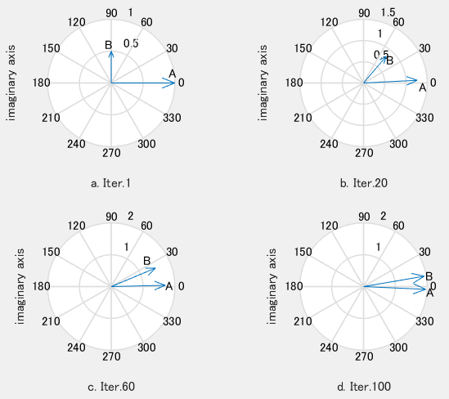

Figure 2. The stroboscopic configurations of these
two members recovered from their trajectories.

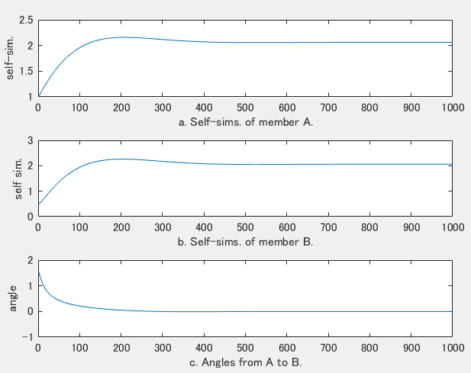

Figure 3. Changes in self-similarities of these members as well as the angle between them over time.

Figure 4 is another possible scenario of the solution of
Model I, in which case N=3 (i.e., triadic relation), m=2
(i.e., a quadratic model). In this case, very complicated trajectories are observed (Chino, 2016).

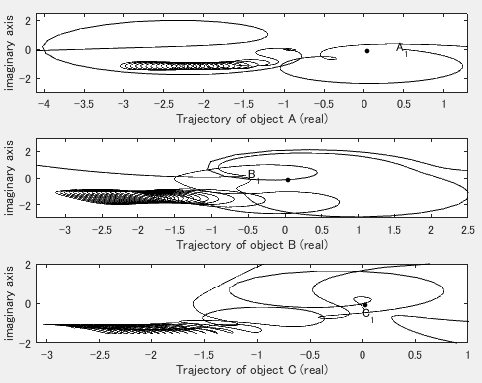
Figure 4. Changes in trajectories of a triad in a one-dimensional Hilbert space.

Figure 5 depicts the stroboscopic configurations of these three members recovered from the above trajec- tories shown in Fig. 4. We can see that the three members gradually approach each other as time proceeds.
Figure 6 draws changes in self-similarities of the three members over time. We can see that the self- similarities increase suddenly at an earlier stage, decrease suddenly, and vibrate repeatedly.

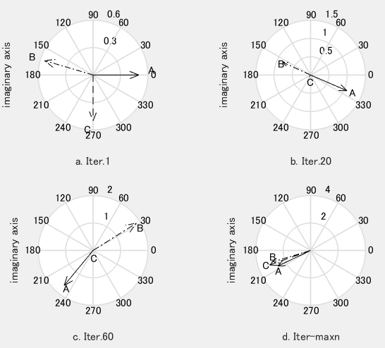

Figure 5. The stroboscopic configurations of the triad recovered from the above trajectories depicted in Fig. 4.

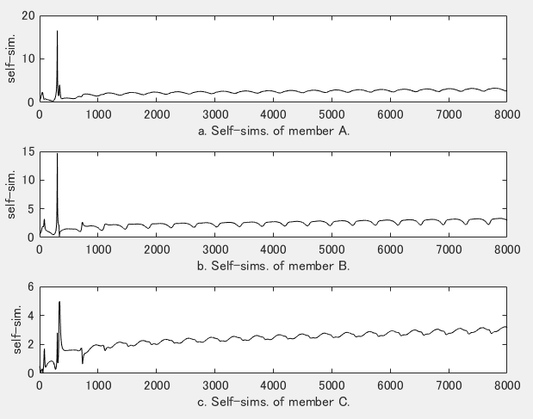

Figure 6. Changes in self-similarities of the three members over time.

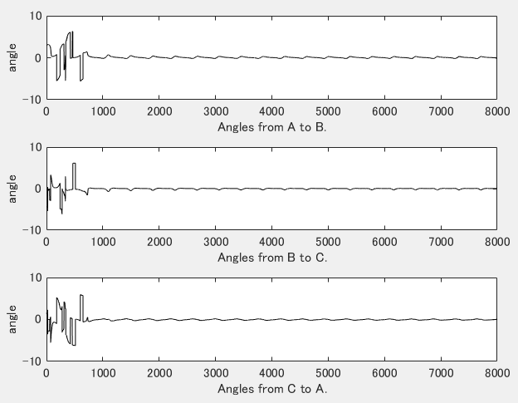

Figure 7. Changes in the angles among three members over time.

Figure 7 depicts changes in the angles among three members over time. We can see that the angles change violently at an earlier stage, and vibrate weakly after that stage.

- Relations to dissipative structure and so on
Finally, we shall refer to the relations of our models discussed here to earlier works, mainly to works on dissipative structure. Our models may be classified as a network model such as the perceptron (e.g., Rosenblatt, 1958; Rumelhart et al., 1986), the recurrent neural network (RNN) (e.g., Hopfield, 1984; Sato, 1990), the automata (specifically, finite automata) (Kleene, 1956), the cellular automaton (e.g., von Neumann & Burks, 1966), the symbolic dynamics (e.g., Hedlund, 1969; Kitchens, 1998), and so on.
Although neural network models such as the perceptron, RNN, and finite automata include input-output units in principle, our models do not include them. In this sense, our models are similar to the cellular automaton. Moreover, both our models and the cellular automaton utilize a set of difference equations. However, the former is different from the latter in that the former utilizes (complex) Hilbert space as the state space of the system, while the latter does not.
In any case, our models enable us to depict various spatiotemporal structures of members of any group, which are considered to evolve through asymmetric interactions among members. Changes in these spatiotempral structures through such interactions can be thought of as a self-organizing phenomenon. In fact, an even simpler system described by one of our models can exhibit, for example, a fixed point behavior (Figure 1), a chaotic behavior, and so on. Then, one might imagine dissipative structures to operate in such a phenomenon.
At present we can, at least, discriminate between a mathematical dissipative system by Levinson (1944) and the dissipative structure by Nicolis and Prigogine (1977). The former is a two-dimensional nonautonomous system which is periodic in t with period L and whose trajectory eventually lies inside of a circle with center at 0, as time proceeds. In contrast, the latter is attained in an open system far from the equilibrium.
In general, it seems to be not so easy to define such a kind of dissipative structure in the strict sense in the phenomena observed in the social and behavioral sciences which we deal with in our model. However, it may be possible, at lease, to define a computational energy func- tion originated by Hopfield (1982) and used elsewhere (e.g., Grossberg, 1988; Müezzinoğlu et al., 2003).

- Linear and non-linear TSA of changes in asymmetric relatioships

As pointed out in Chino (2015a, b), we can utilize various basic tools for the analysis of these time series signals, in order to examine basic properties of these time series signals obtained by our simulation study. We can utilize autocorrelation and power spectrum. Since these tools assume the stationarity of the signals, some caution must be exercised when we compute these indexes.

For example, the time series shown in Figure 6 (i.e., self-similarities data) seems to be nonstationary, because the means gradually increase as time proceeds. In contrast, the time series depicted in Figure 7 (i.e., angle data) seems to be stationary except for the earlier stage.

If we are interested in examining whether there exist some chaotic structures in the signals, we may compute Lyapunov exponents of the signals (Lyapunov, 1892, 1992). In this case ergodicity is assumed in these signals (e.g., Oseldec, 1968; Sano & Sawada, 1985). If we want to check whether or not some fractal structure is contained in these signals, we may for example compute their correlation dimension (Grassberger & Procaccia, 1983). A promising tool for examining the properties of these signals is the recurrence plot of the signals (Eckmann et al., 1987), since it neither assumes the stationarity nor ergodicity of the signals. Figure 1 (Chino, 2015b) shows an example, in which case $w_{jk}= 0.01\left(1+i\right)$, and $w_{kj}=-0.02\left(1+i\right)$, where i is the pure imaginary number.

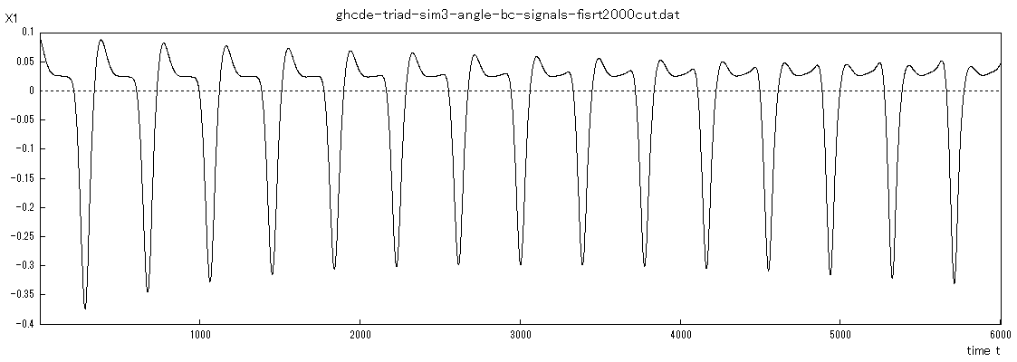
Figure 8. Changes in the angle from member B
to C ranging from the first 2000 to 8000 itera-
tion.

The time series shown in Fig. 8 might be said to have a chaotic property, since the largest Lyapunov exponent of this series is positive. Figure 9 shows the recurrence plot of this series.

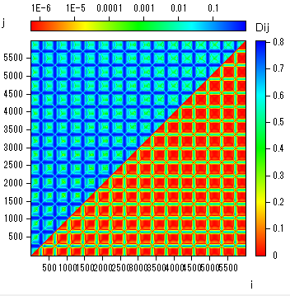
Figure 9a.

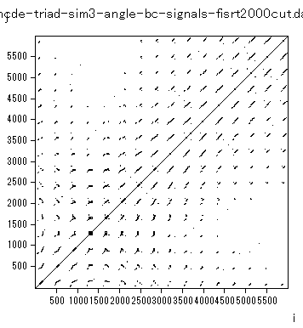
Figure 9b.

Figure 9. The recurrence plot of the time
series shown in Figure 8.

References

Bak, J. & Newman, D. J. (1982). Complex Analysis, New York:Springer-Verlag.
Chino, N. (2000). Complex differential system models of social interaction. Bulletin of the Faculty of Letters of Aichi Gakuin University, 30, 43-54.
Chino, N. (2002). Complex space models for the analysis of asymmetry. In S. Nishisato, Y. Baba, H. Bozdogan, & K. Kanefuji (Eds.) Measurement and Multivariate Analysis. Tokyo: Springer. Pp. 107-114.
Chino, N. (2014). A general non-Newtonian n-body problem and dynamical scenarios of solutions. Proceedings of the 42nd annual meeting of the Behaviormetric Society of Japan (pp. 48-51), Sendai, Japan.
Chino, N. (2015a). A simulation study of a Hilbert state space model for changes in affinities among memers in informal groups. Journal of the Institute for Psycho- logical and Physical Science, 7, 31-47.
Chino, N. (2015b). Time series analyses of changes in asymmetric relationships among members over time. Proceedings of 43th annual meeting of the Behavior- metric Society of Japan (pp.398-401), Tokyo, Japan.
Chino, N. (2016). A general non-Newtonian n-body problem and dynamical scenarios of solutions. Handout presented at the 31th International Congress of Psychology, Yokohama, Japan.
Chino, N. & Shiraiwa, K. (1993). Geometrical structures of some non-distance models for asymmetric MDS. Behav- iormetrika, 20, 35-47.
Eckmann, J. P., Kamphorst, S. O., & Ruelle, D. (1987). Recurrence plots of dynamical systems, Europhysics Letters, 5, 973-977.
Elaydi, S. N. (1996). An introduction of difference equations. New York:Springer.
Grassberger, P., & Procassica, I. (1983). Measuring the strangeness of strange attractors. Physica D, 9, 189-206.
Grossberg, S. (1988). Nonlinear neural networks: Prin- ciples, Mechanisms, and Architectures. Neural Networks,
1, 17-61.
Hamilton, J. D. (1994). Time Series Analysis. Princeton: Princeton University Press.
Hedlund, G. A. (1969). Endomorphisms and automorphisms of the shift dynamical system. Mathematical Systems Theory, 3, 320-375.
Hopfield, J. M. (1982). Neural networks and physical systems with emergent collective computational abilities. Proceedings of National Academy of Sciences, 79, 2554-2558.
Hopfield, J. J. (1984). Neurons with graded response have collective computational properties like those of two-state neurons. Proceedings of the National Academy of Sci- ences, 81, 3058-3092.
Kitchens, B. P. (1998). Symbolic Dynamics. Berlin: Springer.
Kleene, S. C. (1956). Representation of events in nerve nets and finite automata. In C. E. Shannon & J. McCarthy (Eds.), Automatic Studies (AM-34) (pp.3-41). Princeton: Princeton University Press.
Levinson, N. (1944). Transformation theory of non-linear differential equations of the second order. Annals of Mathematics, 45. 723-737.
Lyapunov, A. M. (1892). The general problem of the stability of motion (in Russian). Kharkov: Kharkov Mathematical Society.
Lyapunov, A. M. (1992). The general problem of the stability of motion (translated into English by A. T. Fuller). Inter-
national Journal of Control, 55, 531-773.
Müezzinoğlu, M. K., Güzeliş, C., & Zurada, J. M. (2003). A new design method for the complex-valued multistate Hopfield associative memory. IEEE Transactions on Neural Networks, 14, 891-899.
Nicolis, G. & Prigogine, I. (1977). Self-organization in non-
Equilibrium systems –From dissipative structures to order through fluctuations. New York: Wiley.
Oseledec, V. I. (1968). A multiplicative ergodic theorem. Lijapunov characteristic numbers for dynamical systems. Transactions of Moscow Mathematical Society, 19, 197-231.
Ott, E., Grebogi, C., & Yorke, J. A. (1990). Controlling chaos. Physical Review Letters, 64, 1196-1199.
Rosenblatt, F. (1958). The perceptron: A probabilistic model for information storage and organization in the brain. Psychological Review, 65. 386-408.
Rumelhart, D. E., Hinton, G. E., & Williams, R. J. (1986). Learning representations by back-propagating errors. Nature, 323, 533-536.
Saburi, S. & Chino, N. (2008). A maximum likelihood method for an asymmetric MDS model. Computational Statistics and Data Analysis, 52, 4673-4684.
Sano, M., & Sawada, Y. (1985). Measurement of the Lyapunov Spectrum from a chaotic time series. Physical Review Letters, 55, 1082-1085.
Sato, M. (1990). A learning algorithm to teach spatio- temporal patterns to recurrent neural networks. Biolo- gical Cybernetics, 62, 259-263.
Von Neumann, J. & Burks, A. W. (1966). Theory of self-reproducing automata. Illinois: University of Illinois Press.

